Name: _________________________ May 31, 2018
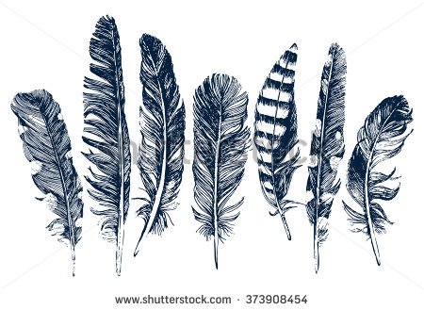

Cinquain Poetry
Cinquain = 5-line stanza
PART ONE:
Think of a feather. Then, complete the chart below:
List One:
Describe the look, feel, and color of a FEATHER.

List Two:
Words that explain the actions and movements of a FEATHER.

List Three:
List emotions or feeling words connected to a FEATHER.

List Four:
List synonyms or a conclusion for the word FEATHER.

PART TWO:
Use your brainstorm about the feather to write a cinquain about a FEATHER.

____________________________________
(line one – object/topic – 2 syllables)

_______________________________________________________
(line two – use ideas from list one – 4 syllables)

__________________________________________________________________
(line three – use ideas from list two – 6 syllables)

_______________________________________________________
(line four – use ideas from list three – 8 syllables)

____________________________________
(line five – use ideas from list four – 2 syllables)

PART THREE:
Think of a any object/topic of your choice.
What is it? ______________________________________________________
Now, complete the chart below:
List One:
Describe the look, feel, and color of it.

List Two:
List words that explain the actions and movements of it.

List Three:
List emotions or feeling words connected to it.

List Four:
List synonyms and conclusion ideas for it.

PART FOUR:
Use your brainstorm to write a cinquain about your choice of object/topic.

____________________________________
(line one – object/topic – 2 syllables)

_______________________________________________________
(line two – use ideas from list one – 4 syllables)

__________________________________________________________________
(line three – use ideas from list two – 6 syllables)

_______________________________________________________
(line four – use ideas from list three – 8 syllables)

____________________________________
(line five – use ideas from list four – 2 syllables)

