Name: _______________________________________________ May 29, 2018
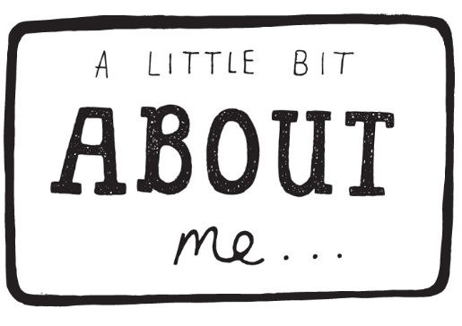
Writing a ME Poem!

Follow the directions below to write a poem or two about yourself.

PART ONE: Answer the questions below.
Think about who you were four or five years. What were you like then? How are you the same now? How are you different now? Give a specific memory that you have that would show the difference.
___________________________________________________________________________________________________________________________________
___________________________________________________________________________________________________________________________________
___________________________________________________________________________________________________________________________________
___________________________________________________________________________________________________________________________________
___________________________________________________________________________________________________________________________________
___________________________________________________________________________________________________________________________________
___________________________________________________________________________________________________________________________________
___________________________________________________________________________________________________________________________________
___________________________________________________________________________________________________________________________________
___________________________________________________________________________________________________________________________________

PART TWO: Complete the chart to get you thinking of who you were then and who you are now.
QUESTION | THEN | NOW
How you looked …

What you did with your time …

What you liked/didn’t like ..

What you were/are afraid of …

What you thought/think or believed/believe …

What you couldn’t do then/ what you can’t do now …

What you got in trouble for …

What makes you sad …

What makes you happy …

PART THREE: Use the organizer and the sentence starters below to create a Me Poem. When you are finished, create a title that is intriguing and creative.
Helpful hints …
- Use one pair of sentences to describe your physical appearance.

- Think about something you used to do and something you do now.
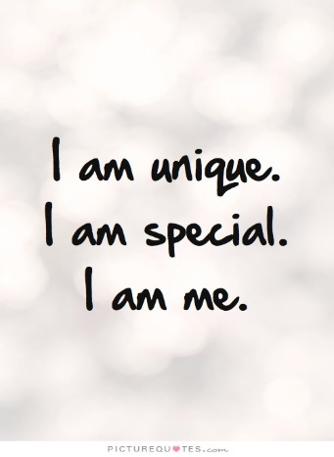

- Describe something you used to fear and something you fear now.

- Describe what used to anger you and what angers you now.

- Adapt the sentence beginnings if necessary …
  - I used to be …; I may become …
  - I used to like …
  - I used to believe …
  - I used to have …
  - I used to wish …

There are two examples on the back of this page.
When you feel ready, take a graphic organizer for the Me Poem!

